Experiment No 1.3

**Create Application by Using Widgets**

<https://www.geeksforgeeks.org/how-to-create-a-basic-widget-of-an-android-app/>

**Widgets** are the micro-version of the application that consists of some functionality of the application that is displayed only on the **Home Screens** or the **Lock Screen**. For example, we see **Weather**, **Time**, **Google Search Bars** on the Home Screen, and **FaceLock**, **FingerprintLock** on the Lock Screen, which are some of the Widgets available on the device. Widgets come along with the Application when you install it or download it from the Web. Generally, phones come with a manufacturing configuration but such elements can be adjusted by a user later in time. In this article, we demonstrate how one can implement a basic widget for an Android App.

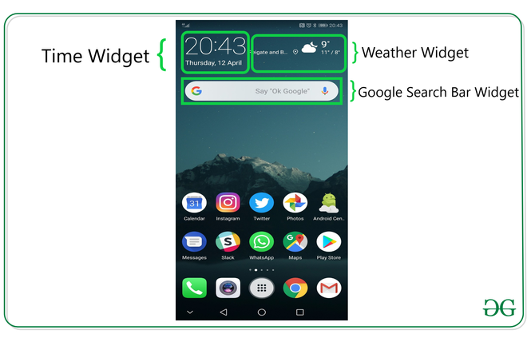

**Steps for Creating a Basic Widget**

**Step 1: Create a New Project**

To create a new project in Android Studio please refer to [**How to Create/Start a New Project in Android Studio**](https://www.geeksforgeeks.org/android-how-to-create-start-a-new-project-in-android-studio/). We are implementing it for both **Java**and **Kotlin**languages.

**Step 2: Add the App Widget to the Project**

Right-Click on the **app**, move the cursor to **new**, find the “**Widget**” option at the end, select it.

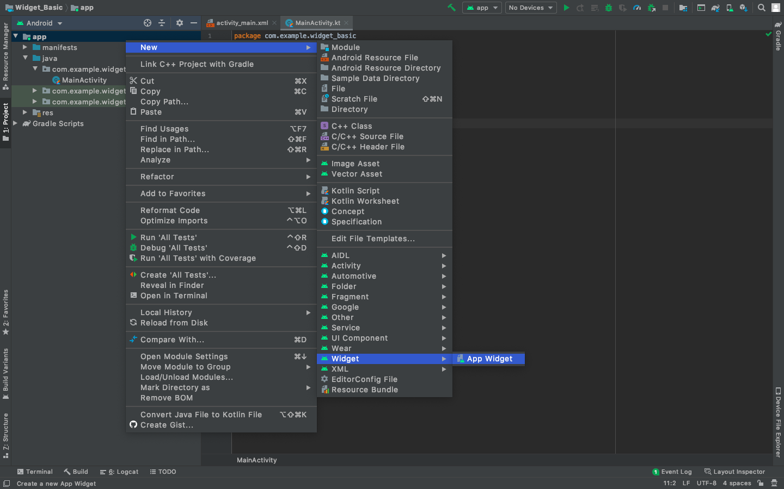

Specify the required properties for the widget such as**min. width** and **height**, config file and preferred language, etc, and proceed. Files are automatically generated.

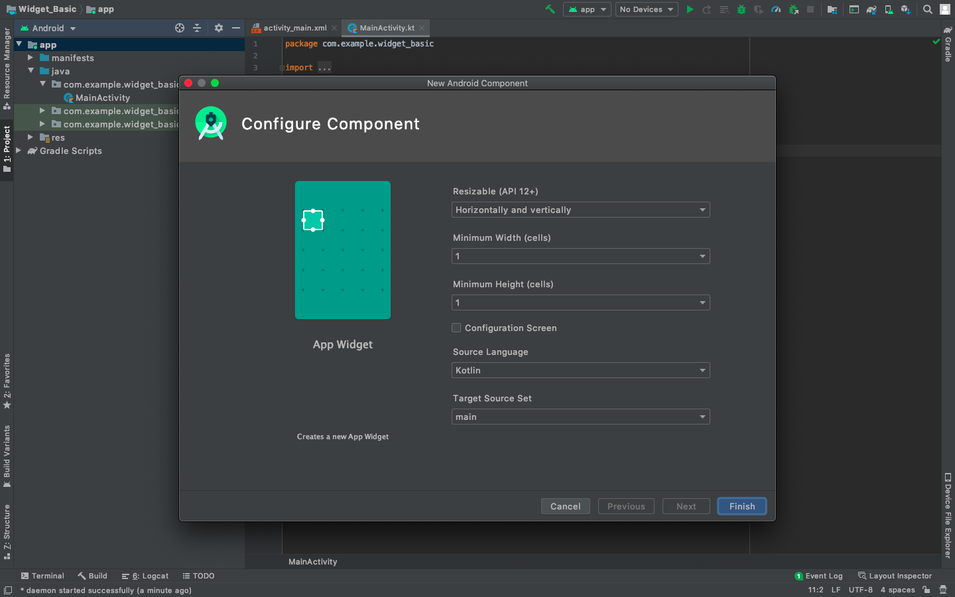

**Step 3: Install and Run the Code**

* Install and Run the code on Android Virtual Device (AVD) or a personal device.
* Open the widget section of the phone, lookup for a widget with the Application name, select it, bring it to the home screen.
* Try changing the dimensions and we are done!

|  |
| --- |
| import android.appwidget.AppWidgetManager  import android.appwidget.AppWidgetProvider  import android.content.Context  import android.widget.RemoteViews    // Implementation of App Widget functionality.  class NewAppWidget : AppWidgetProvider() {      override fun onUpdate(          context: Context,          appWidgetManager: AppWidgetManager,          appWidgetIds: IntArray      ) {          // There may be multiple widgets active, so update all of them          for (appWidgetId in appWidgetIds) {              updateAppWidget(context, appWidgetManager, appWidgetId)          }      }        // Enter relevant functionality for      // when the first widget is created      override fun onEnabled(context: Context) {        }        // Enter relevant functionality for      // when the last widget is disabled      override fun onDisabled(context: Context) {        }  }    internal fun updateAppWidget(      context: Context,      appWidgetManager: AppWidgetManager,      appWidgetId: Int  ) {      val widgetText = context.getString(R.string.appwidget_text)      // Construct the RemoteViews object      val views = RemoteViews(context.packageName, R.layout.new_app_widget)      views.setTextViewText(R.id.appwidget_text, widgetText)        // Instruct the widget manager to update the widget      appWidgetManager.updateAppWidget(appWidgetId, views)  } |

**2. new_app_widget.xml**

Where it’s generated?

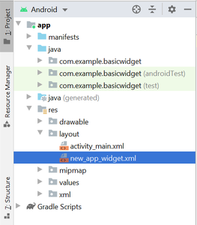

* XML

|  |
| --- |
| <RelativeLayout      xmlns:android="<http://schemas.android.com/apk/res/android>"      android:layout_width="match_parent"      android:layout_height="match_parent"      android:background="#09C"      android:padding="@dimen/widget_margin">        <TextView          android:id="@+id/appwidget_text"          android:layout_width="wrap_content"          android:layout_height="wrap_content"          android:layout_centerHorizontal="true"          android:layout_centerVertical="true"          android:layout_margin="8dp"          android:background="#09C"          android:contentDescription="@string/appwidget_text"          android:text="@string/appwidget_text"          android:textColor="#ffffff"          android:textSize="24sp"          android:textStyle="bold|italic" />    </RelativeLayout> |

**3. dimens.xml**

Where it’s generated?

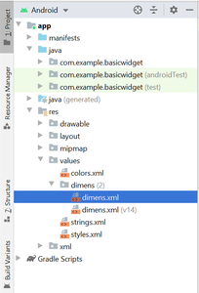

* XML

|  |
| --- |
| <?xml version="1.0" encoding="utf-8" |